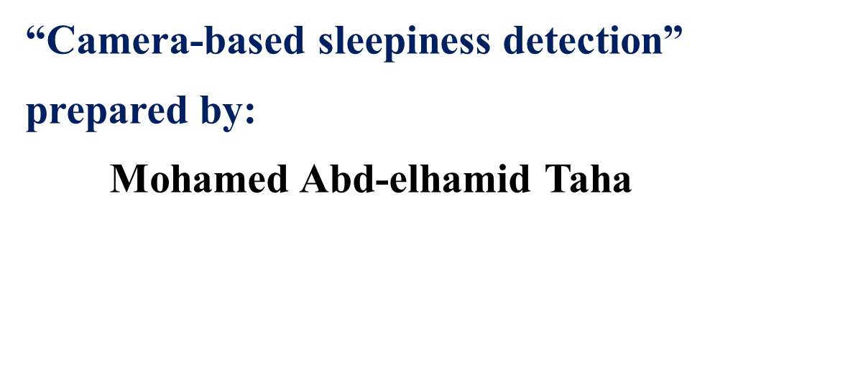

* **The Problem**

**According to a special study by the American Automobile Association The results of this study indicate that sleeping or sleeping behind the wheel is a cause of about 300,000 accidents a year, of which 6,400 are fatal. And because driver fatigue and therefore low concentration while driving can be very dangerous.**

* **Solution**
* **“Camera-based sleepiness detection “, This technique allows detection of the initial state of the driver's light sleepiness by accurately measuring the driver's condition without any physical contact, including blinking features, facial expressions, etc., from signals captured by a camera installed in the car, and then processing these signals using artificial intelligence.**
* **This technique detects the light sleepiness that the driver doesn't even realize by himself, by measuring blindfolds, facial expressions and other criteria. If the device is sensed that there is a new and continuous mode of driving that is due to low concentration while driving, it issues an audio alarm and activates the warning orange light, which takes the form of a coffee cup, while showing a message written in the meter cavity screen asking the driver to stop for a break.**

 **Objectives**

* **Reduction of road accidents that occurs daily.**
* **Develop a low-cost data acquisition unit for head and eye**

**tracking based data.**

* **Providing the device with high level from performance and speed.**
* **Achieving the highest possible satisfaction rate for drivers.**

**Resources**

** Materials:**

* **Metal for manufacture of headphone, camera, and wires from copper.**
* **Lithium battery that is rechargeable.**
* **Microphone for isolation the noise.**
* **Silicon cover for protection of headphone.**
* **Polycarbonate for rear cover and body of camera.**
* **View –specific lens.**
* **APS-C sensor.**

**Specifications:**

* **It works with 1080 pixels with night vision and the field of view reaches 130 degrees.**
* **PIR motion detection feature and with small size.**
* **Full HD image display.**
* **Head phone weighs only 15 grams.**
* **Frequency response ranging from 20Hz to 20KHz and headset sensitivity reaching 92 dB.**
* **The headphone sounds more than awesome and design is great.**
* **Long battery life.**
* **The device is the size of a Bluetooth headset, It has a frequency-based circuit inside it that monitors the driver's bare head movement.**

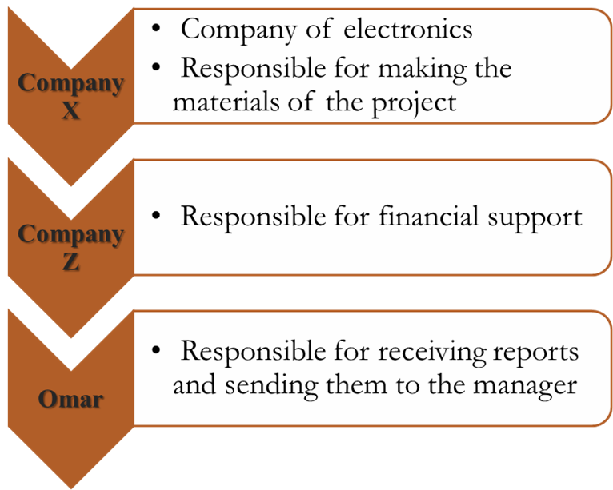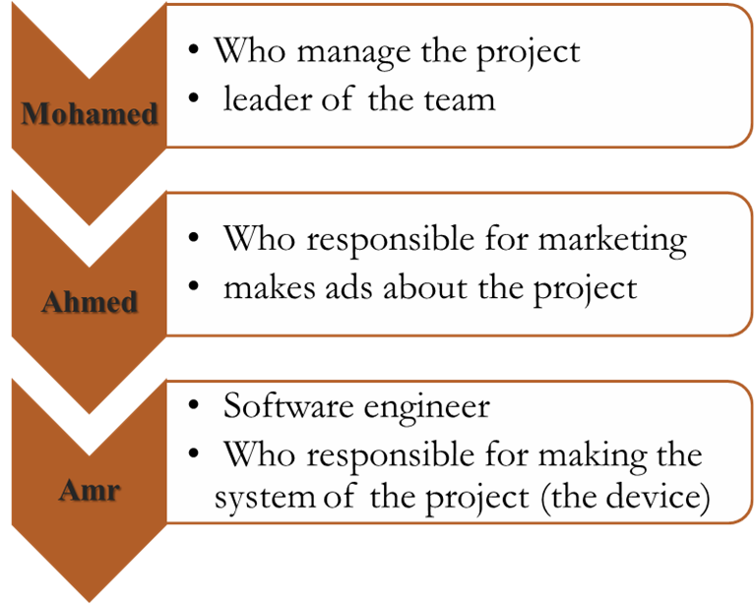 **Stakeholders and Roles**

 **The budget**

* **Total Cost: 250,000$**
* **The price of the device: 500$**
* **Free trial: 500,000$**
* **Team: 100,000$**

**Project Risk**

**Technical Risk**

*  **Performance: maybe not high therefore we will need time to solve this problem.**
* **System: if the system is not compatible with the device but we will solve this problem as much as we can.**
* **Requirements & Materials: maybe the company cannot manufacture the materials as we need it so we will be exposed to loss in the materials.**

**Management Risk**

* **the sponsor: it is possible the sponsor does not like the designing so we will change the designing and that takes time.**
* **the experience of marketing specialist: the marketing specialist does not have enough experience but we will provide courses for him.**

**External Risk**

* **Economic**
* **Environment**

**Project Scope**

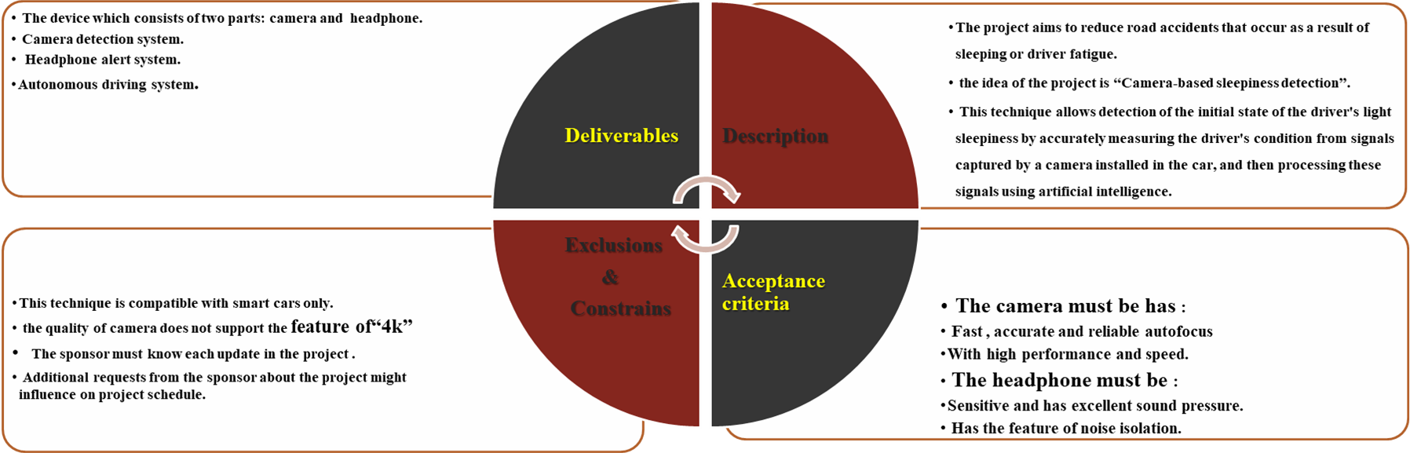

**Work Breakdown Structure (WBS)**

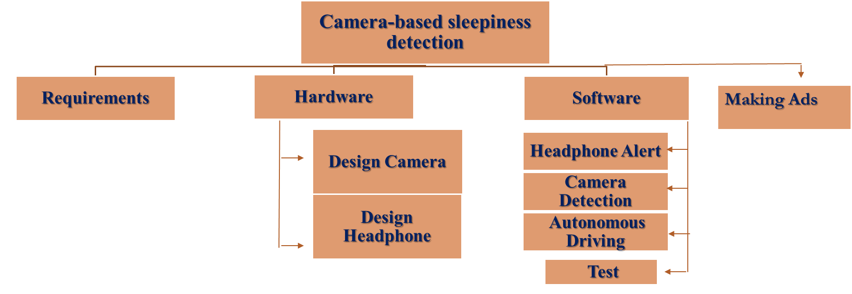

**Responsibility Matrix**

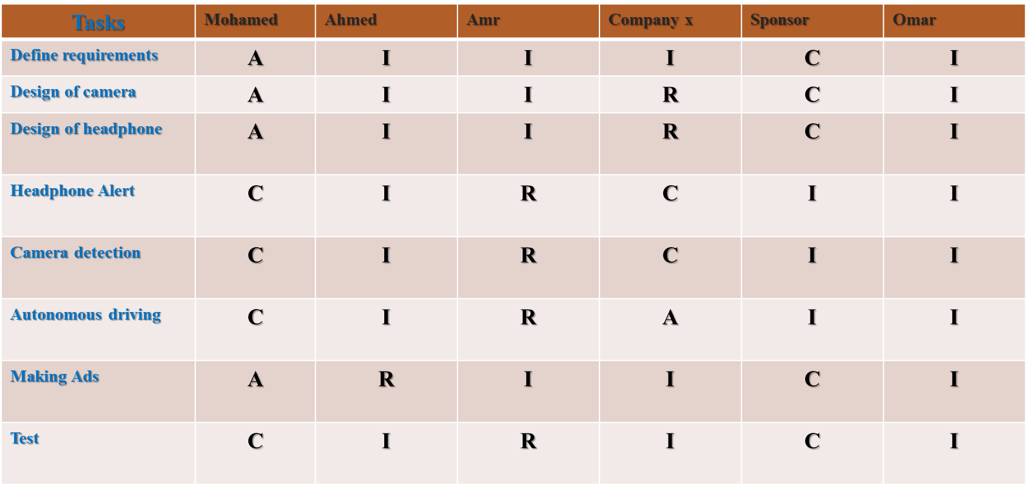

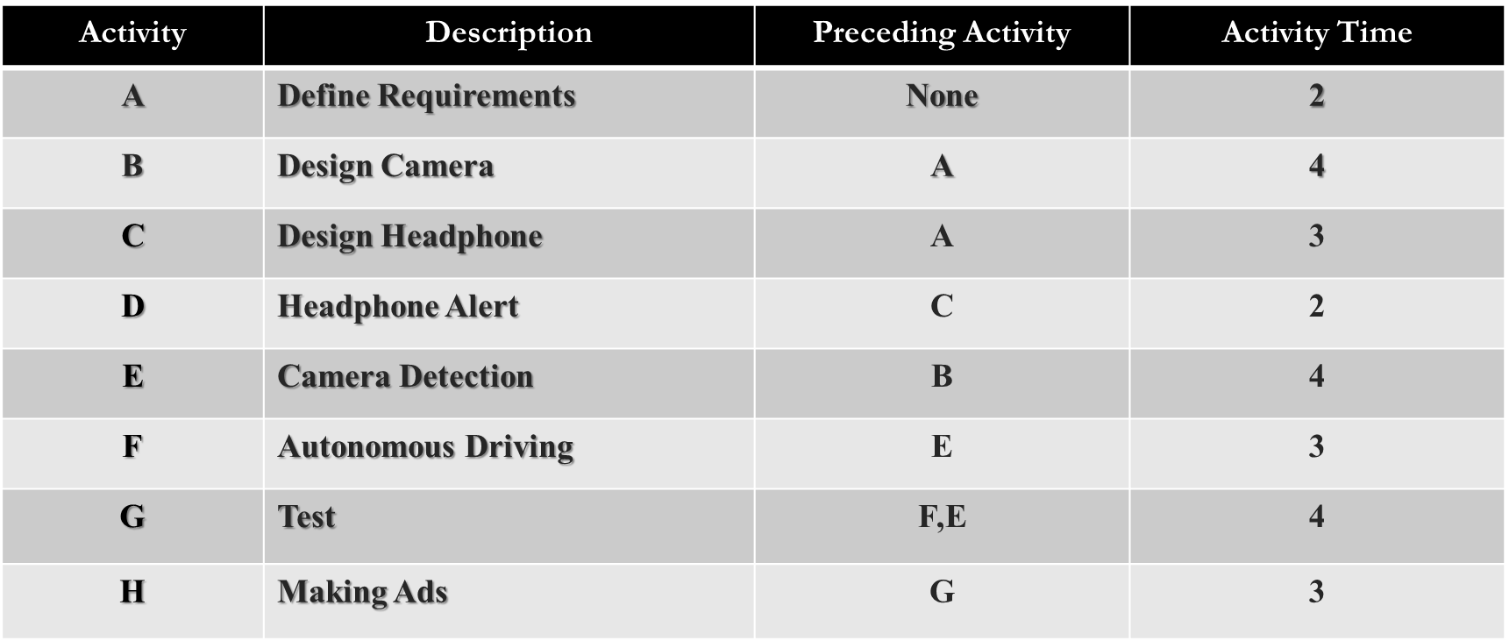 **Information Network**

**Project Network**

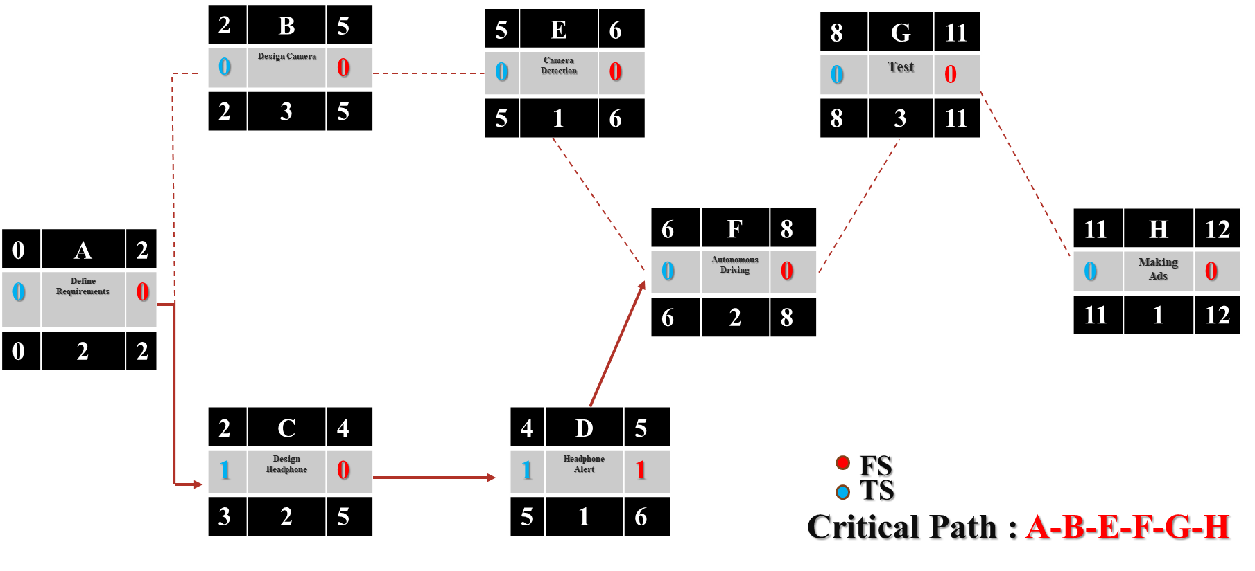

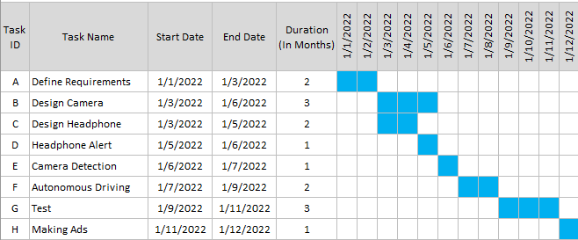 **Project Gantt Chart**

**Resource-Constrained Schedule**

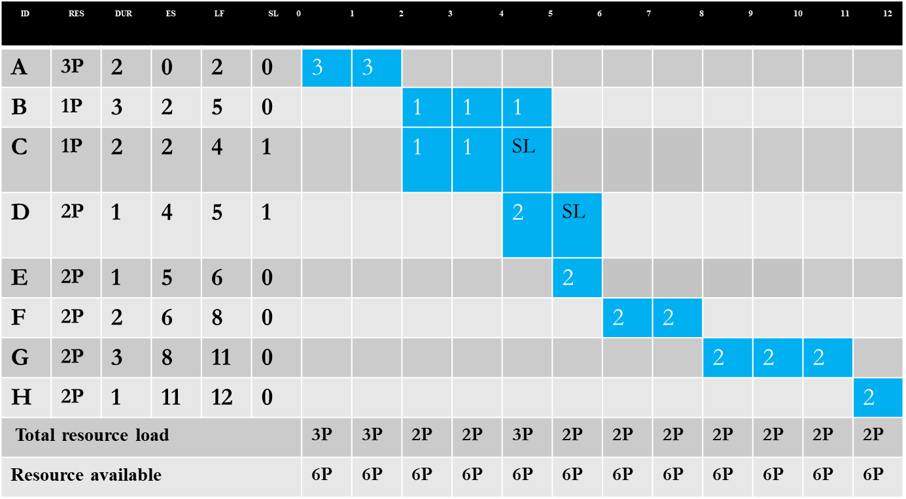

**Resource scheduled network**

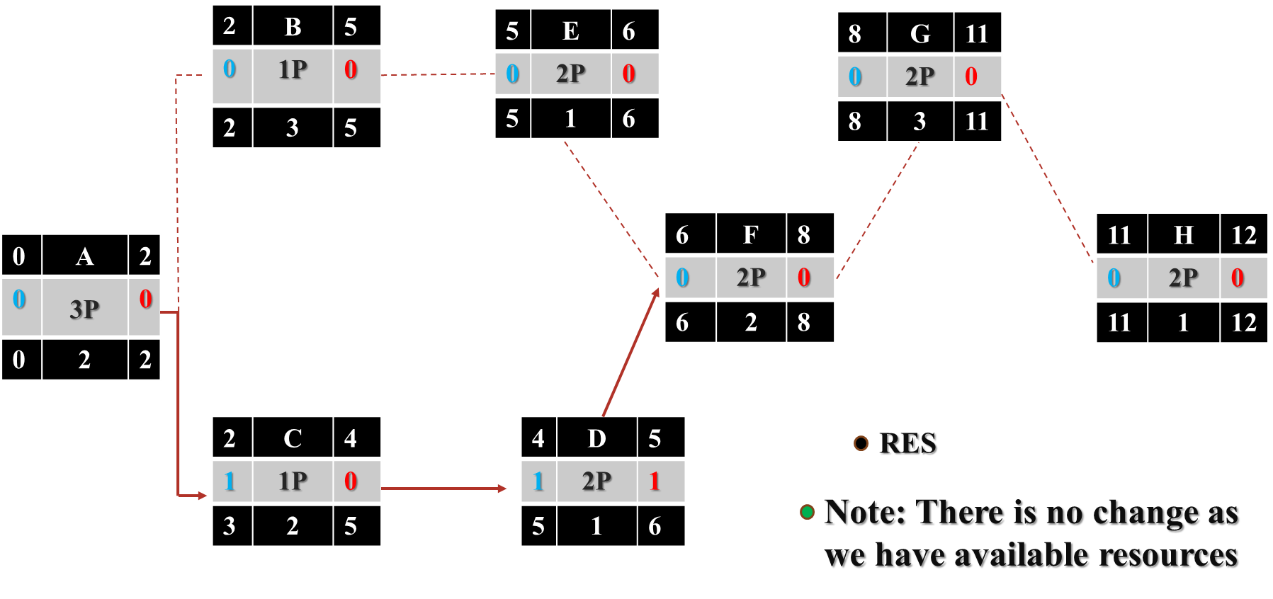

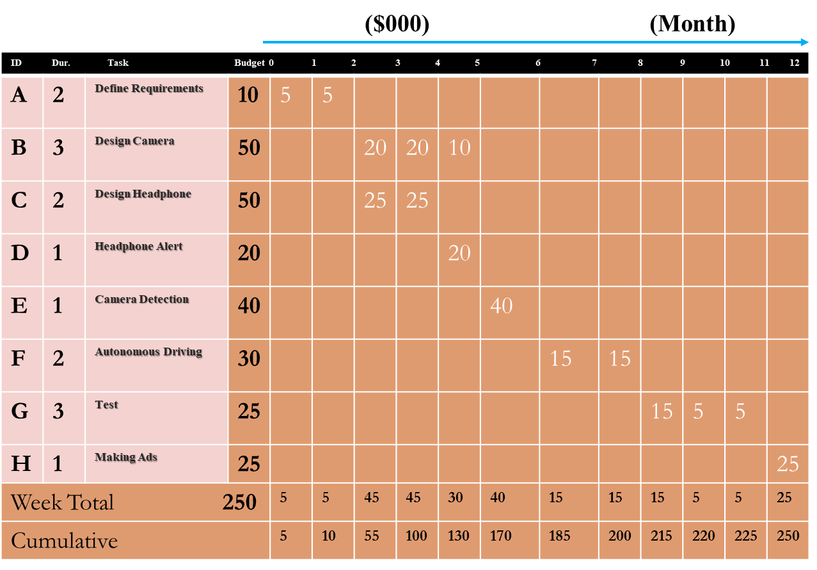 **Time-Phased Work Packages**

**Cumulative Baseline Budget (PV)**

